**Four color theorem**

Color a map on paper and the colors of *adjacent regions (excluding a point)* should not share the same color. How many colors do you need?

This question has baffled mathematicians for more than a century and was first posted a s a puzzle to the public in the end of the 19th century. It was finally proved in 1977 by Appel and Haken that indeed no more than 4 colors are required using a computer’s assistance.

Try coloring this!

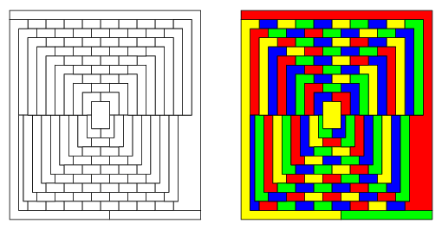

Mathematicians can be clever tricksters. On April Fools day, the famous Mathematician, Martin Gardner posted this image having 110 regions and said it can be colored in 5 colors and no less and put all mathematicians in a frenzy that the four color theorem was debunked.

**Why computers?**

This problem has been fed to computers to solve. Computers are the usual guinea pigs when human brains can’t transcend.

We human beings like to quantify and rate everything. So a computer is considered a winner against human brains only if it can solve the problem very fast even if we feed it a very huge picture to color.

So people who wrote programs/steps to be followed by the computer were baffled on what exact commands (algorithm) to give to the computer such that coloring huge maps does not take a lot of time.

Computers are supposed to solve problems in a jiffy however huge the problem is. It still remains a mystery.

.

**Our class**

At the schools in Mumbai that CuriosityGym has it’s Innovation Hubs. This was a problem which we wanted to introduce to the students.

But a simple hypothetical map coloring sheet to judge the number of colors following some rules alone cannot be learning enough.

**Where is this used practically?**

It is used in sudoku puzzle solvers, facebook uses it for friend connections. We needed a simple example for the students’.

We gave them a use case.

They have different after school activities:

* Karate
* Drums
* Innovation Hub
* Capoeira
* Public Speaking

and different students’ enrolled for each after school activity.

The school now has to decide how to schedule the activities such that the students

* who have chosen common activities don’t have to give up on their preferences
* and the school chooses minimum number of slots

considering the each activity is on all five days of the week.

The students’ drew a conflict graph and colored the graph to see the minimum number of slots required.

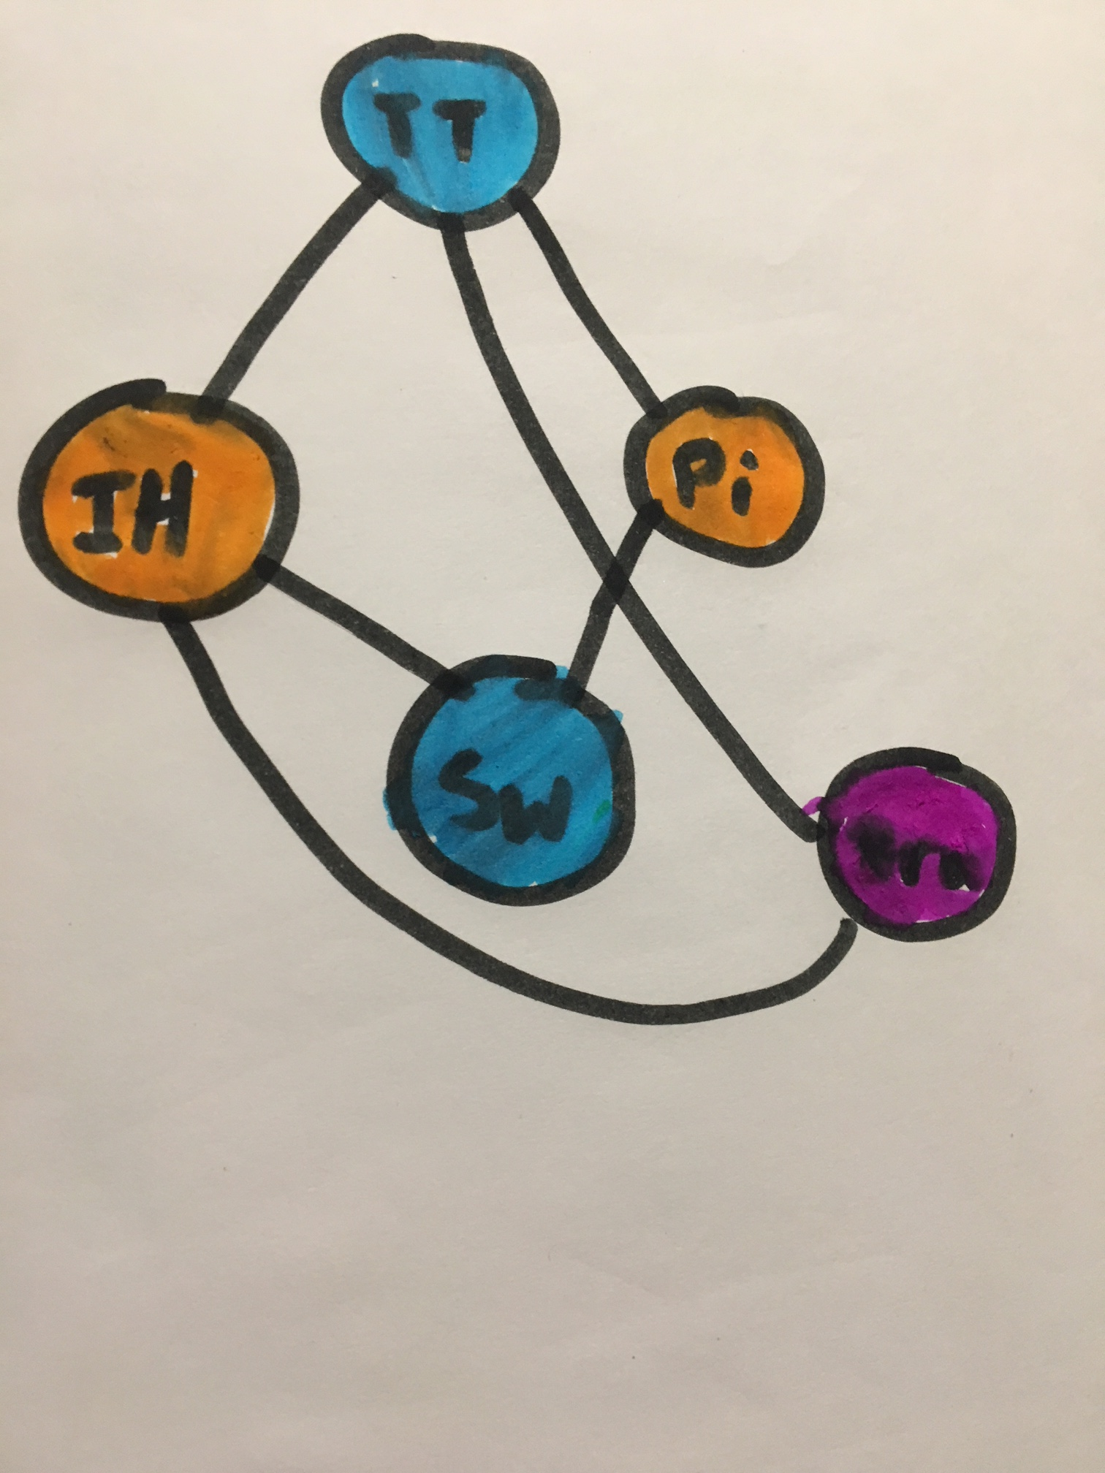

TT: Table Tennis

IH: Innovation hub

SW: Swimming

Pi: Piano

Dru: Drums

The students’ ended up using three colors: Blue, Orange and Violet for five different activities. Means that the school can assign the same time slot for the same colors but different slots for the different colors since there was a clash.

**A program to color a map?**

Mr.Girish asks me can you make a computer color a map, and not plain shapes? Thanks to Mr. Rupin, who introduced us to D3.js recently, Mr. Girish suggested we could use D3.js to color the map programmatically.

Now which algorithm do we use?

There are many. I chose the greedy algorithm.

And what map? Chose the largest, the world map.

The world map, does not have contiguous regions, those places would obviously choose another color.

**What is greedy?**

The map regions are vertices (circles) in a graph and the adjacent regions are connected by edges (lines).

The regions are selected in a particular order. A new color is chosen if the neighbors have the same color or use the smallest unused available color.

With this we don’t find the best solution but a reasonable enough one.

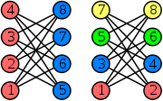

Ordering them the other way leads to 4 colors instead of 2.

**Greedy with D3.js**

As expected the coloring gave me 5 colors. The black regions are the fifth color.

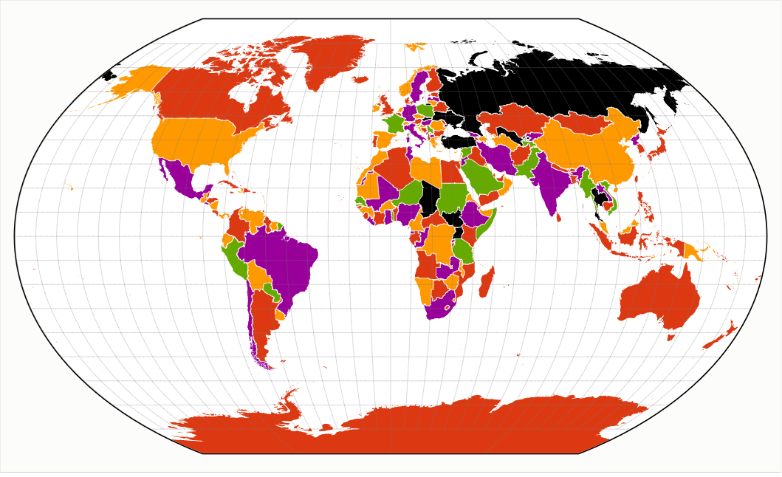

Refer to: <https://bl.ocks.org/sahirvsahirv/59bd76257777ac919bcf7ace4cc377c7>

**Can do better?**

Certainly, can use:

* Welsh Powell: The countries (vertices) are ordered according to the number of neighbors.
* Baktracking: Trace back when you make an error choosing the color or you end up with the fifth color
* Genetic algorithms
* Artificial intelligence
* Divide the problem amongst multiple computer processors